SCHOOL OF COMPUTER SCIENCE AND ARTIFICIAL INTELLIGENCE |  |  |  |  | DEPARTMENT OF COMPUTER SCIENCE ENGINEERING
ProgramName:M. Tech |  |  |  | Assignment Type: Lab |  |  | AcademicYear:2025-2026
CourseCoordinatorName |  |  |  | Venkataramana Veeramsetty
CourseCode |  |  |  | CourseTitle |  | AI Assisted Problem Solving Using Python
Year/Sem |  |  | II/I | Regulation |  | R24
Date and Day  of Assignment |  |  | 10.11.2025 | Time(s)
Duration |  |  | 2 Hours | Applicableto  Batches
AssignmentNumber:8.3(Present assignment number)/24(Total number of assignments)
 | Q.No. | Question |  |  |  |  |  | ExpectedTime  to complete
 | 1 | Lab 8: Test-Driven Development with AI – Generating and Working with Test Cases  Lab Objectives:  - To introduce students to test-driven development (TDD) using AI code generation tools.  - To enable the generation of test cases before writing code implementations.  - To reinforce the importance of testing, validation, and error handling.  - To encourage writing clean and reliable code based on AI-generated test expectations.  Lab Outcomes (LOs):  After completing this lab, students will be able to:  - Use AI tools to write test cases for Python functions and classes.  - Implement functions based on test cases in a test-first development style.  - Use unittest or pytest to validate code correctness.  - Analyze the completeness and coverage of AI-generated tests.  - Compare AI-generated and manually written test cases for quality and logic  Task Description#1  Use AI to generate test cases for is_valid_email(email) and then implement the validator function.  Requirements:  - Must contain @ and . characters.  - Must not start or end with special characters.  - Should not allow multiple @.  Expected Output#1  - Email validation logic passing all test cases  Prompt: Write a python function for Email validation and allow user to give user input to check the code.  Code:  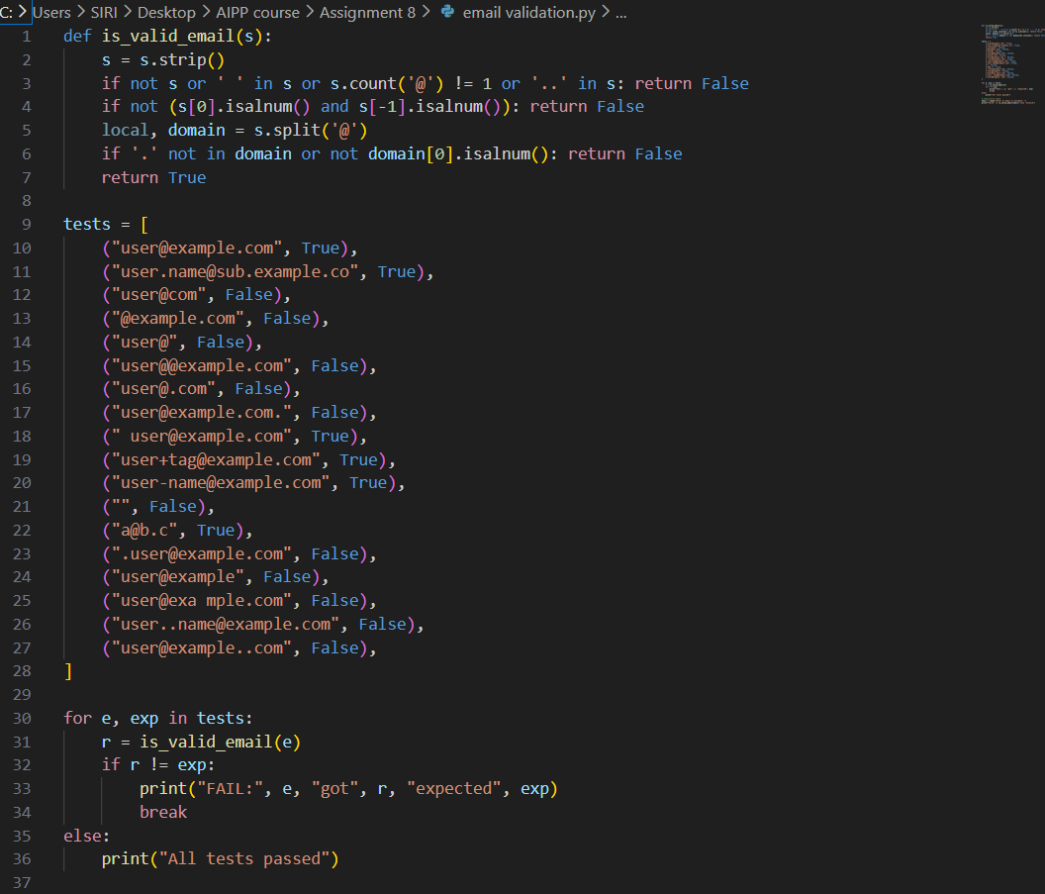  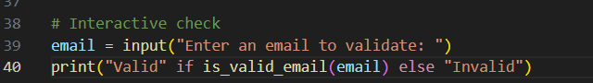  Code Explanation:  - Strips whitespace and rejects empty strings or any string containing spaces.  - Requires exactly one @ and rejects consecutive dots (..) to avoid malformed addresses.  - Ensures the email does not start or end with a non-alphanumeric character (no special chars at ends).  - Splits on @ and requires the domain part to contain a . and begin with an alphanumeric character.  - Runs a set of test cases (expected True/False) first, then prompts the user to enter an email for an interactive validity check.  Output:  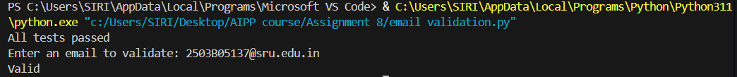  Task Description#2 (Loops)  - Ask AI to generate test cases for assign_grade(score) function. Handle boundary and invalid inputs.  Requirements  - AI should generate test cases for assign_grade(score) where: 90-100: A, 80-89: B, 70-79: C, 60-69: D, <60: F  - Include boundary values and invalid inputs (e.g., -5, 105, "eighty").  Expected Output#2  Grade assignment function passing test suite  Prompt: Write a python function to assign grades based on requirements and allow user to give user input to test the code.  Code:  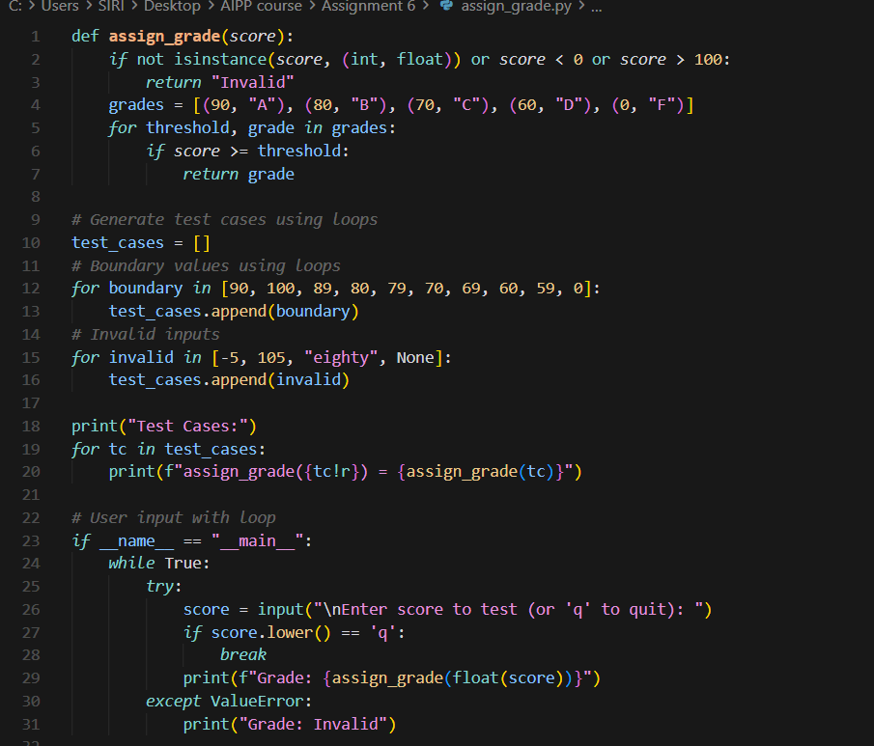  Code Explanation:  - The function checks if the given score is a valid number between 0 and 100; otherwise, it returns "Invalid".  - It goes through grade thresholds and returns A, B, C, D, or F based on the score.  - A list of test cases is created, including boundary values and invalid inputs.  - Each test case is passed to the function, and the result is printed.  - The program allows the user to enter scores repeatedly and shows the grade until they type 'q' to quit.  Output:  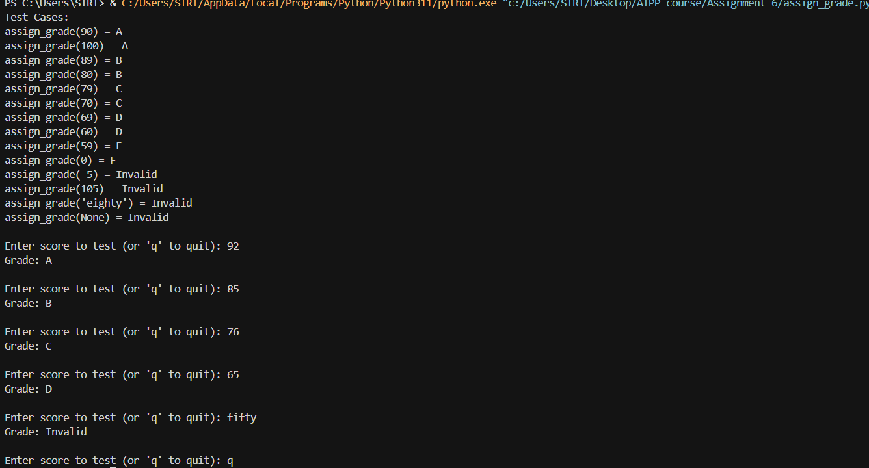  Task Description#3  - Generate test cases using AI for is_sentence_palindrome(sentence). Ignore case, punctuation, and spaces  Requirement  - Ask AI to create test cases for is_sentence_palindrome(sentence)  (ignores case, spaces, and punctuation).  - Example:  "A man a plan a canal Panama" → True  Expected Output#3  - Function returns True/False for cleaned sentences  - Implement the function to pass AI-generated tests.  Prompt: Write a python program for is_sentence_palindrome(sentence) and allow user to give input to test the code.  Code:  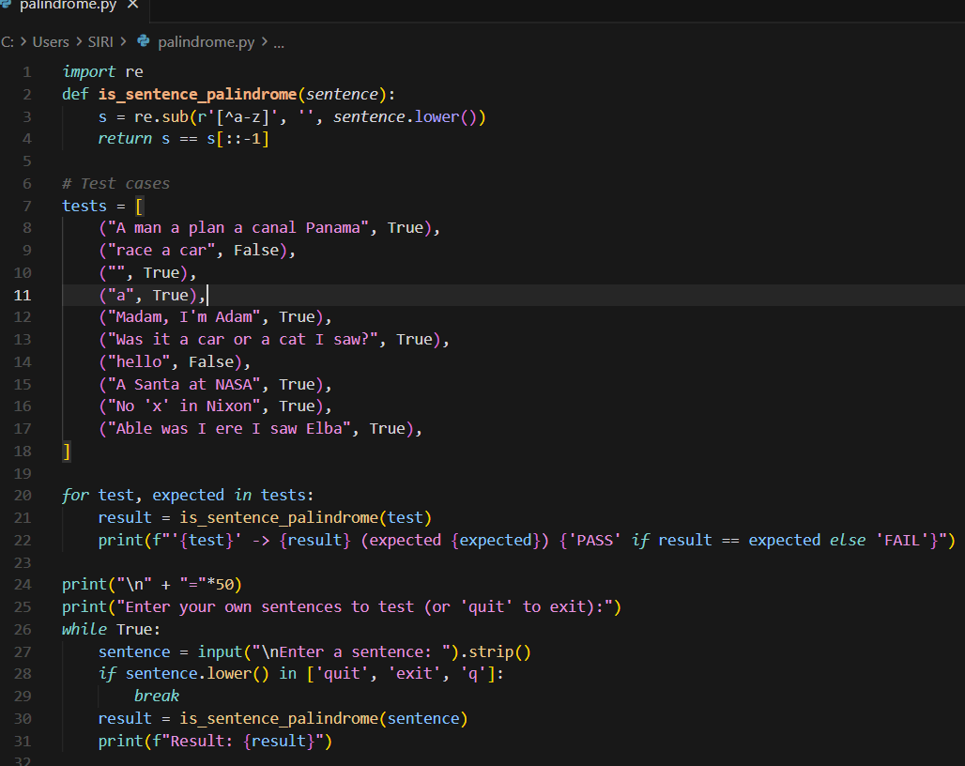  Code Explanation:  - The function first removes all characters except lowercase letters using a regular expression, so only alphabetic characters are checked.  - It converts the sentence to lowercase to make the palindrome check case-insensitive.  - It compares the cleaned string with its reverse; if both are the same, it's a palindrome.  - A list of test sentences is checked one by one, printing whether each result matches the expected output.  - The program then enters a loop where the user can input sentences, and it prints whether each one is a palindrome until the user types "quit", "exit", or "q".  Output:  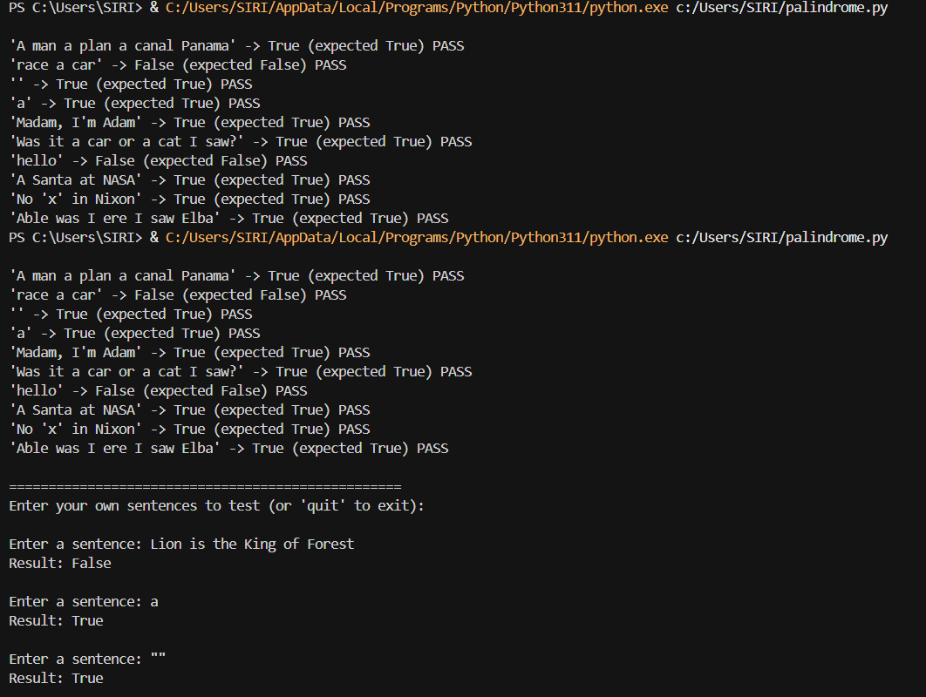  Task Description#4  - Let AI fix it Prompt AI to generate test cases for a ShoppingCart class (add_item, remove_item, total_cost).  Methods:  Add_item(name,orice)  Remove_item(name)  Total_cost()  Expected Output#4  - Full class with tested functionalities  Prompt: Generate a complete Python class named ShoppingCart with methods add_item(name, price), remove_item(name), and total_cost(). Also create comprehensive automated test cases to verify all functionalities. And allow user to give user input to test the code.  Code:  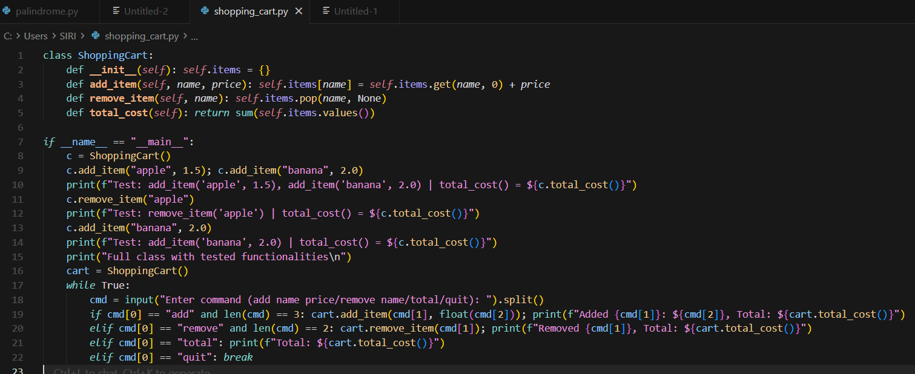  Code Explanation:  - The class keeps all items in a dictionary where each item name stores its total price.  - The add_item function adds a new item or increases its price if it already exists.  - The remove_item function deletes an item from the cart if it is present.  - The total_cost function adds up all item prices and returns the final amount.  - The main program tests these functions and also lets the user add, remove, or check the total using commands.  Output:  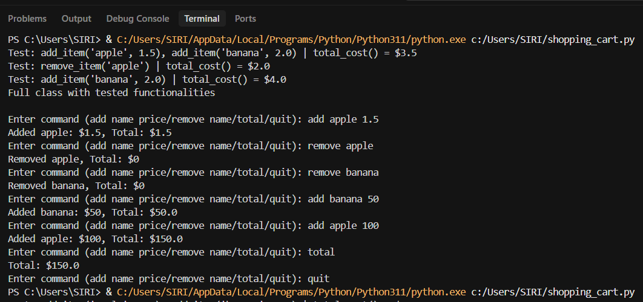  Task Description#5  - Use AI to write test cases for convert_date_format(date_str) to switch from "YYYY-MM-DD" to "DD-MM-YYYY".  Example: "2023-10-15" → "15-10-2023"  Expected Output#5  - Function converts input format correctly for all test cases  Prompt: Generate a Python function convert_date_format(date_str) that converts dates from 'YYYY-MM-DD' to 'DD-MM-YYYY', and create multiple test cases to verify that the function works correctly for all user inputs.  Code:  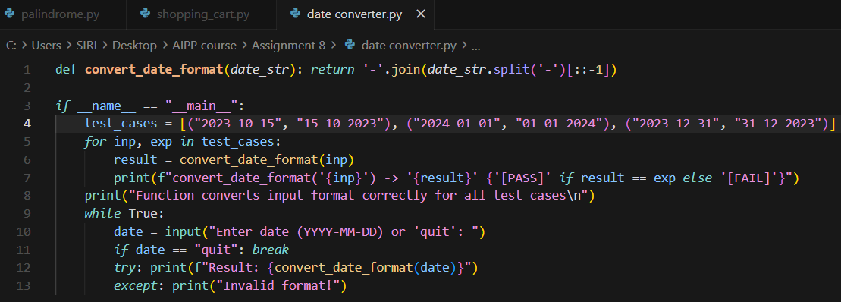  Code Explanation:  - The function splits the date by dashes and reverses the parts to change the order.  - It then joins the reversed parts back together with dashes to form the new format.  - A list of test cases checks whether the function gives the expected converted dates.  - Each test prints PASS or FAIL based on whether the output matches the expected result.  - The program then lets the user enter dates and shows the converted format until they type "quit".  Output: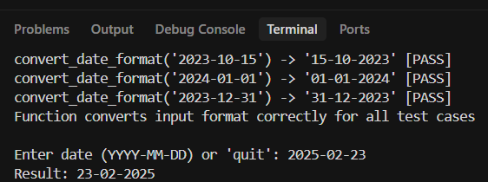  Note: Report should be submitted a word document for all tasks in a single document with prompts, comments & code explanation, and output and if required, screenshots |  |  |  |  |  | Week4 - Wednesday

